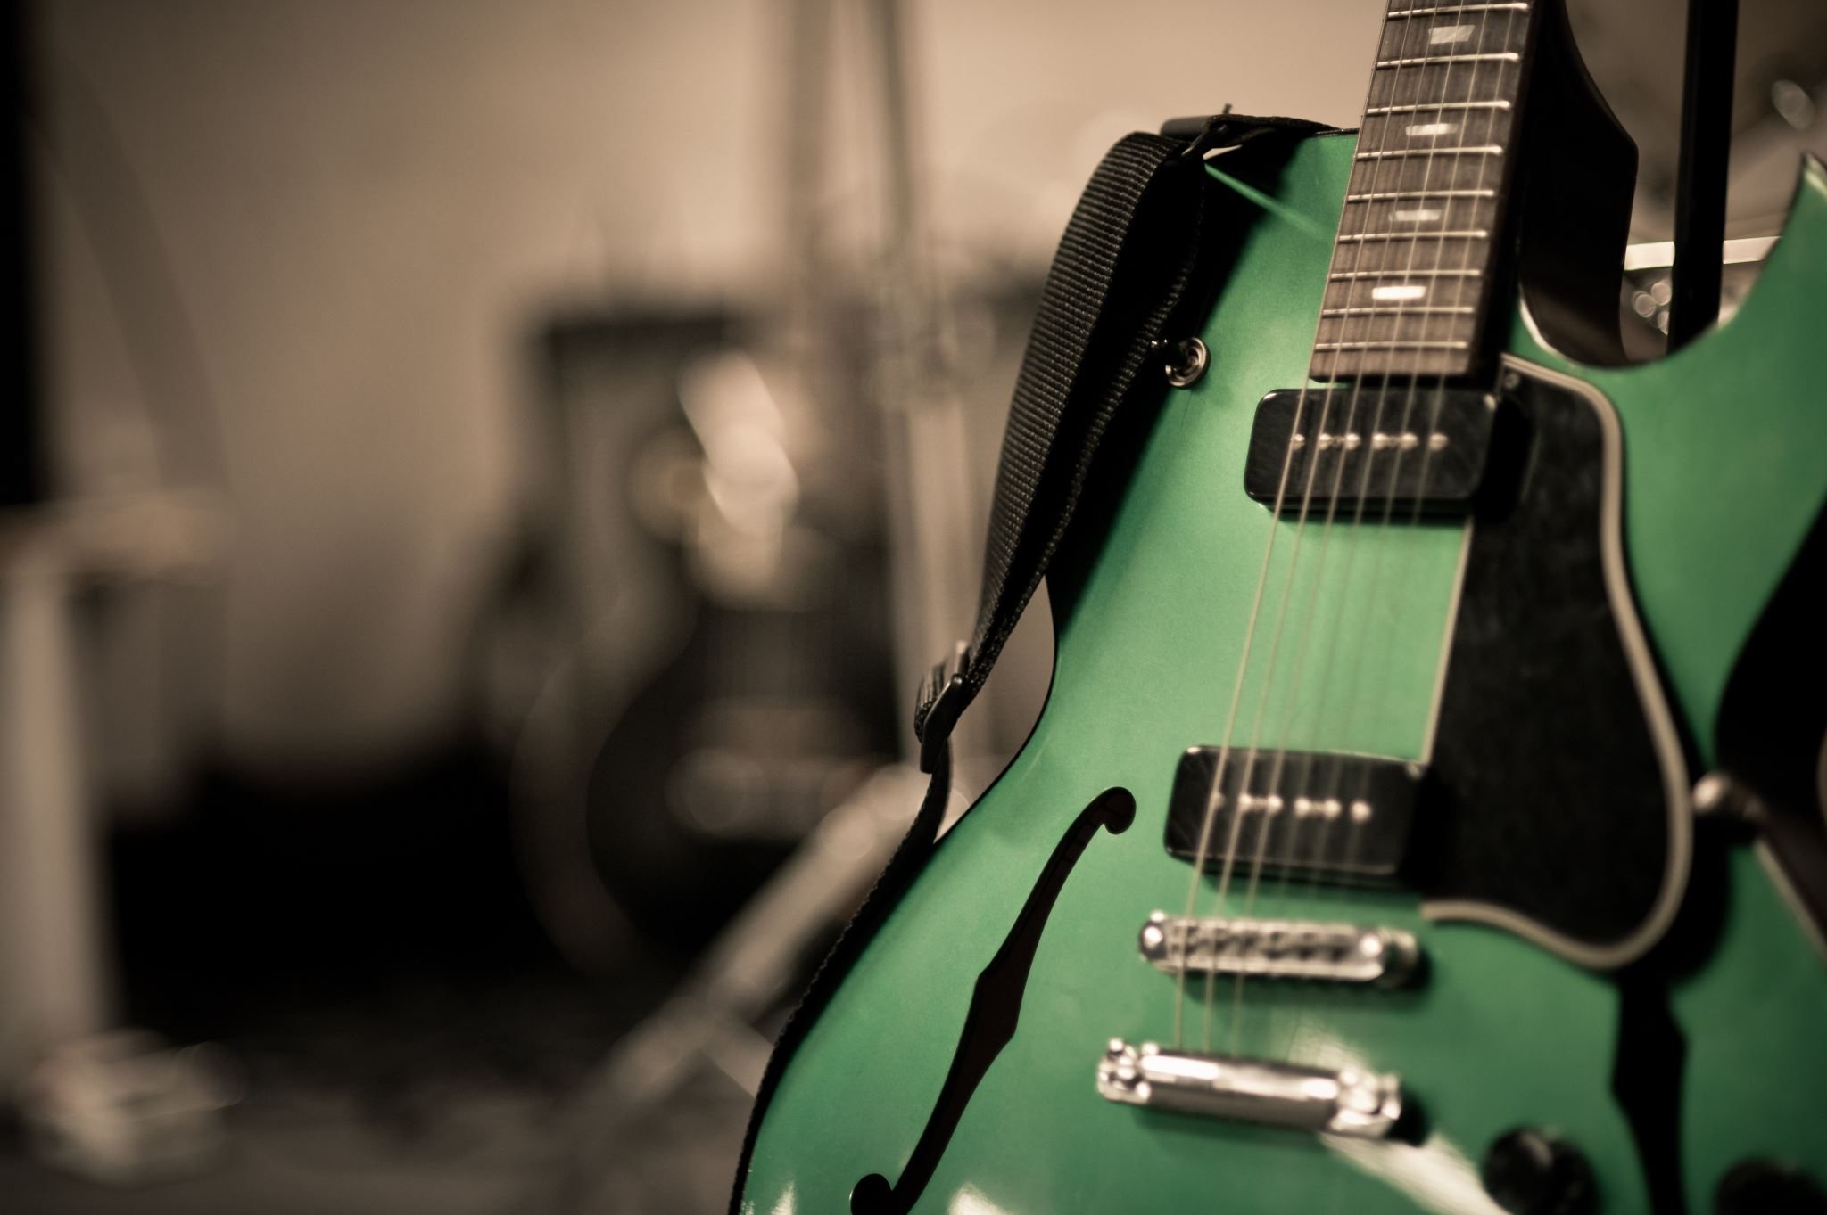**Team**

**<Data Bass>**

**Team Coordinator:** Nathan Dow nmd210001  
  
**Team Members:**  Faissal Benelbar fxb210008

Liam George ldg210001

Zain Karime zxk230017

Riley McKinney rhm220001

##### **Summary of Project:**

We will be making a music database. The database will include artists, record labels, and songs as entities. Attributes and relationships will be used to describe songs, their sales and the relevant artist and record labels that own it.